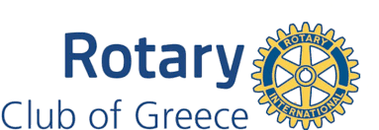

Greece Rotary - Service Above Self Scholarship - Application (for a graduating senior in the Greece School District)

Name: _______________________________________________________________

Parent/Guardian Name: __________________________________________________

Address: ______________________________________________________________

City: ____________ State: _____ Zip: _________ Phone No. ____________________

Student’s e-mail address: _________________________________________________

Parent’s e-mail address: __________________________________________________

High School: _______________________________Class of: ____________________

Education Institution attending in the fall _____________________________________

Expected Major _________________________________________________________

College Student ID# _____________________________________________________

The Four-Way Test:
Of the things we think, say, or do
- Is it the truth?
- Is it fair to all concerned?
- Will it build goodwill and better friendships?
- Will it be beneficial to all concerned?

Submit the Application to levarts001@rochester.rr.com by March31
- Completed Application
- Essay on how you demonstrate The Four-Way Test in your community.
- 2 Letters of Reference.

A $3,000 check made payable to the educational institution will be mailed from the Greece Rotary Club Treasurer. The winner is asked to attend a luncheon meeting to meet the club members.

